AZUR MACHINE LEARNING

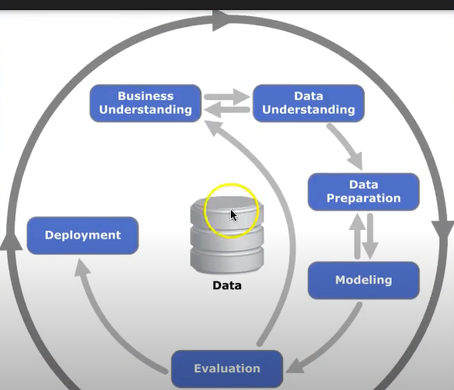

1-Create your free Azur account

[**https://azure.microsoft.com/en-in/free/**](https://azure.microsoft.com/en-in/free/)

After you create your own account, this is the home screen looks like.

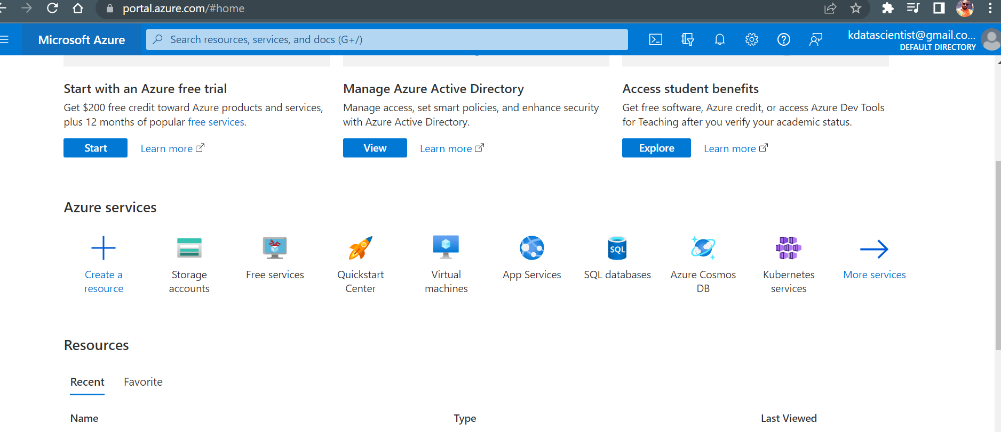

2- Create resources 🡪 search with machine learning 🡪 Create Azure Machine Learning 🡪

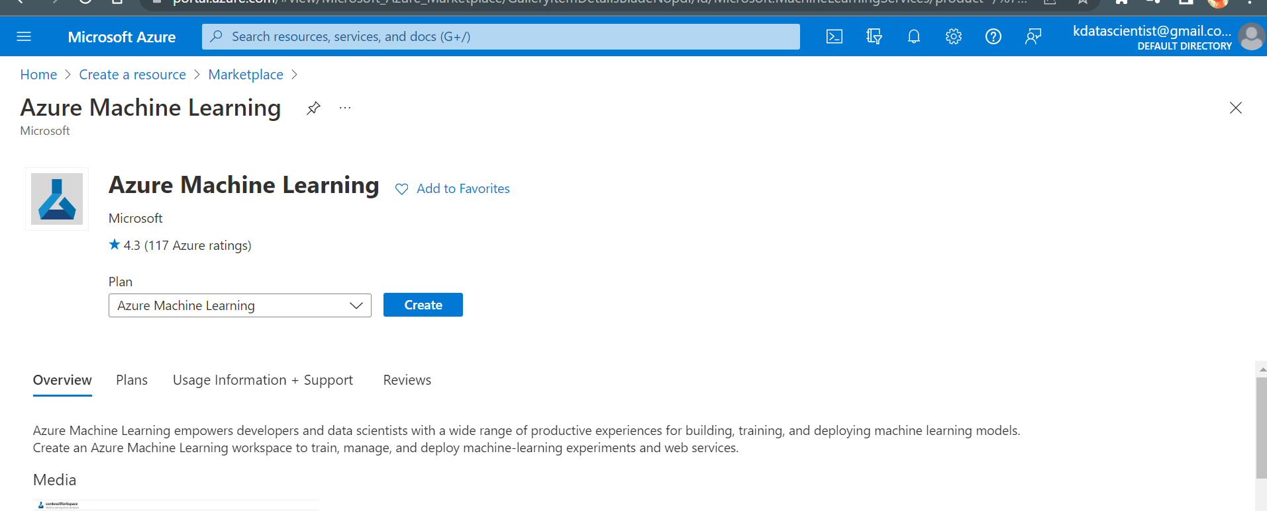

3- Azur ML Studio 🡪 CLASSIC VERSION 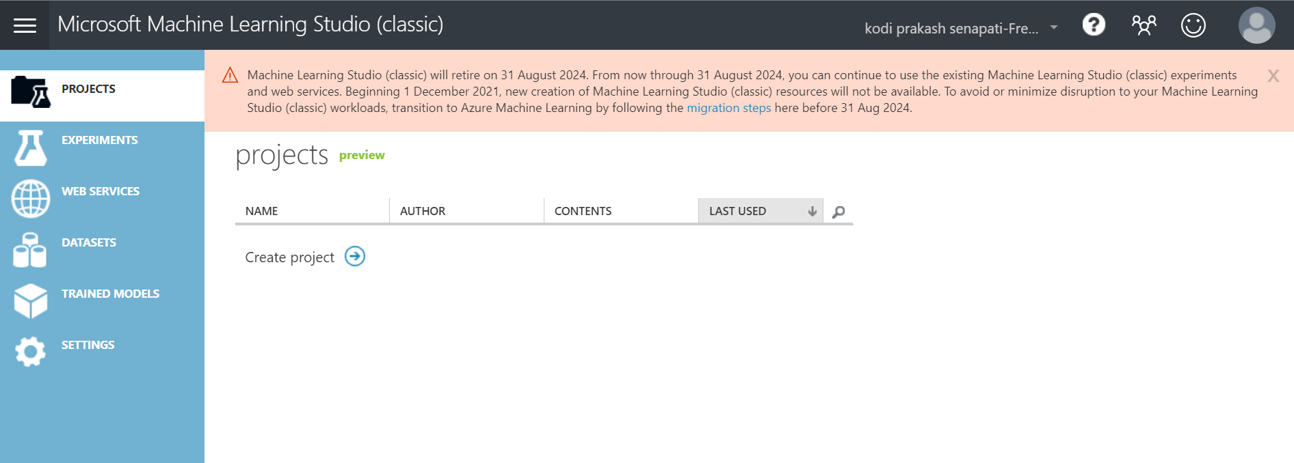

4-Click on datasets 🡪 select New 🡪 Upload the dataset

5- Click on +NEW (Icon found below)🡪 New experiment 🡪 upload the bikebuyer.csv

6- Statistical function 🡪 or you can search with summarized 🡪 Explore this option

7- To know missing values 🡪 search 🡪 missing

8- For Imputation 🡪 data transformation 🡪 scale and reduce 🡪 Normalized data🡪 Launch column selector🡪 Run normalized data🡪 (no column-include-column type-Numeric)->Run selected option

9- right click on normalized data🡪 transformed dataset 🡪 visualize

Let’s work with another dataset 🡪

1- Dataset – Restaurant customer dataset - lets visualize the data

2- write column – Select column in dataset - lunch column selector – select them all – move to right (except userid, latitude, longitude, religion, colour, weight, height) – irrelevant attribute

3- Before we build ml model make sure we need to check do we have any missing value – search with missing – clean missing data - replace with mode – down to that option we need to remove

4- split the dataset – make 75% for training

5- train model – classification – multiclass decision forest – change the parameter based on your requirement

6- to scoring your model (score- one point is connect to train to model // other point is connected to (split data – score model)

7- Evaluate model- run – check all run will turn to be green

8- Deploy web services – you will be redirect to another page – you will get 2 options – request/response & batch execution – click on new webservice experience

9- click on sample data – click on enable (If it automatically fills up then no problem or else you need to enter manually) – test request response

10- Finally you will generate the o/p for ml model

**NOTES REGARDING AZUR ML 🡪**

1 - Create an Azure ML workspace🡪

* create an Azure Machine Learning Workspace
* Configure workspace settings
* Manage a workspace by using Azure ML studio

2- Create storage account 🡪

Home -> storage account -> to create your own storage account -> check the subscription (free trail) -> create Resource group -> storage account (all small letter only) -> click on next till review + create --> finally deployment is completed -> go to resource (storage account created over hear) -> container -> click on +container button -> click on azurmlstbblob -> empty container will get

3- Machine learning studio 🡪

Click on Azurmlstudio -> datastores-> click on blobstore (default) -> click on account name -> container -> blobstorage container link -> upload the dataset to this container -> upload the file -> go to storage browser (preview) -> blob container (azurmlbolob) -> create new virtual directory -> Loan data -> upload blob -> upload the dataset -> go to Microsoft azurml -> datasets -> create dataset -> from data store -> loan application -> dataset type ( tabular) -> next -> datastore selection -> select the datastore where the data is located -> file path ( you can find the dataset location) save the path -> Next ( start parsing the data) -> next -> it will display dataset attribute information (schema) -> I will unfilter the loan id # & gender because both are not important for the dataset -> confirm details -> create -> finally we successfully created loan application dataset -🡪 (( If you want to delate the dataset then you need to unregister dataset))

So far, we created an AzurML workspace 🡪 manage data objects in Azureml workspace -> under manage data objects in azurml workspace – 1> register and maintain datastore 2> create and manage datasets

4- Explore the AZURML dataset ->

Mlstudio -> dataset -> click on loan application -> check on details, consume, explorer, models

5- Create Compute cluster->